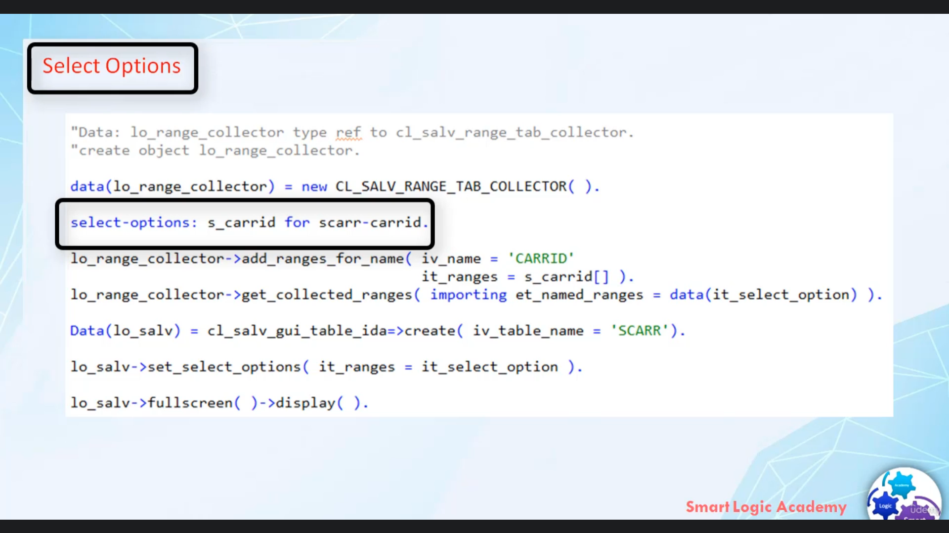

Hi, welcome back.

In this video, I will tell you how you can use select option in a tweet Idir.

For a large amount of data, it is important that the user has the option to restrict the amount of

data that is displayed using selection screen here.

The current example shows how you can use select options to restrict the data your idea displays.

The data retrieval using selection options and display are done by with ideas.

The solution made by user is transferred to the list using Meeta to select options, use Mr Outrange

for name of classic SLV range tab collector to convert the selection of user.

The format that is needed for the six select options used me to get collected range to combine multiple

select options into one internal table.

So that's all about Terri related to select options, now let's create one other people program and

let's you select options in a vivid idea.